1. The aboveground biomass C data came from Fig. 4 (page 165).

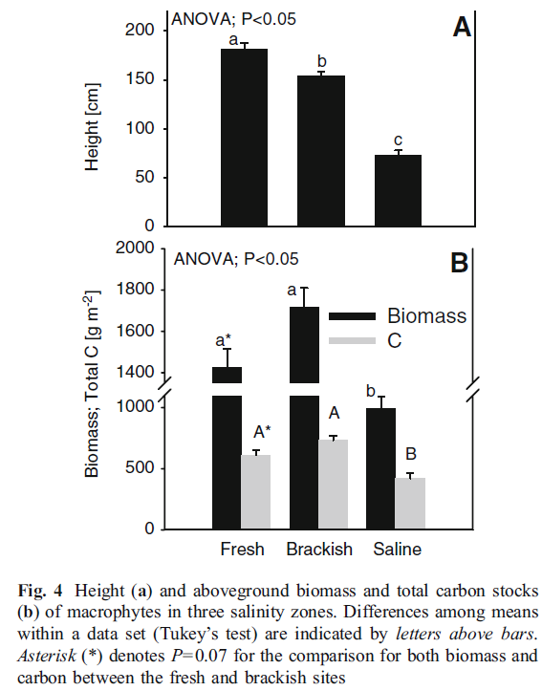

2. The soil C pool data was from Fig. 6 (page 166).

